SAP Milestone Schedule

This Design Bulletin defines the seven minimum milestone dates needed for the Office of Program Management. It is important to standardize project milestones in order to make communication of project information and reporting better at a regional and statewide level.

Cash and Program Management Milestones:
Project Managers must enter specific milestone dates into SAP Project Builder (CJ20N) as part of CDOT’s critical path method scheduling used to manage project schedules. These milestone dates are used by the Office of Program Management (PMO) to develop master program schedules, forecast construction expenditures, and monitor key performance indicators (e.g. SPI - see attachment). Timely and accurate entry and maintenance of milestone dates by the Project Manager is crucial to implementation of program and cash management.

The seven milestones listed in the table below are required for all projects that will be advertised for construction, including design-bid-build, design-build, and construction manager/general contractor (CMGC) projects. Follow regional guidelines for additional milestones that are required.

Design-Bid-Build | CMGC | Design-Build
1. Scoping  2. FIR  3. FOR  4. Ad  5. Late Ad  6. Begin construction  7. End construction | 1. Scoping  2. FIR  3. FOR  4. Ad/CAPP  5. Late Ad/CAPP  6. Begin construction  7. End construction | 1. Scoping  2. Statement of interest (SOI)  3. Draft Request for Proposals (RFP)  4. Final RFP  5. Late Final RFP  6. Begin construction  7. End construction

For projects that are initially set up in SAP before a schedule has been developed, enter the dates for the seven minimum milestones and then update information at Scoping and FIR as project schedules become more clear. Under “Advertised By” enter who will be Advertising the project “State”, “Local”, etc. Ask your Region PMO representative for assistance if you have questions.

In an effort to provide consistency among project schedules, an explanation of when each standard milestone is considered complete is provided in more detail below.

1. Scoping — the Design Scoping Review (DSR) or equivalent meeting has been held, a project schedule has been agreed upon with specialty units, and a preliminary cost estimate has been developed.
2. Field Inspection Review (FIR) — this milestone is achieved when the FIR meeting has been conducted.
3. Final Office Review (FOR) — this milestone is achieved when the FOR meeting has been conducted.
4. Advertisement Date — the date that project is advertised for proposals.
5. Begin Construction — the date that contractor is anticipated to begin work. During the preconstruction phase, use the first of the month as the date. For example, if work is expected to begin in May, use May 1st as the begin date. Reminder: when updating this date, consider whether the project’s draw down schedule needs to be entered or updated to coincide with the Begin Construction date.
6. End Construction — the date is the project acceptance or partial acceptance date with landscape warranty period.
7. Ad/CAPP — the date the Contract Agreed upon Price is requested from the vendor.
8. Statement of Interest – the date the request for Statements of Interest is published.
9. Draft RFP — the date the draft request for proposals (RFP) is published for vendors.
10. Final RFP — the date the final RFP is published for vendors.
11. Late Ad & Late Ad/CAPP & Late Final RFP – the latest a project can go to advertisement and still achieve regional goals
12. Landscape Warranty – the date for the end of the landscape warranty period for projects that have “End Construction” milestone as partial acceptance.

Regions may develop additional guidance or checklists to support the definitions of the above milestones and to further define when the milestone has been achieved.

Additional milestone dates may be needed to manage individual projects depending on the project scope and complexity. The Project Development Manual (PDM) outlines 14 milestones for use in managing projects. CDOT Regions will develop their own policies for the use of these milestones, or additional milestones that they deem needed for the management of projects within the region. Standard milestones, associated with the 14 milestones in the PDM, are encouraged for the ability to generate statewide reporting tools (e.g. CDOT CAR reports, etc.).

Updating dates in Project Builder (CJ20N):

Step 1: Open Design Milestone screen in CJ20N.
In CJ20N drill down to the Design WBS and then click on the Milestone Overview diamond. If there are issues editing, make sure the “pencil” is toggled as well.

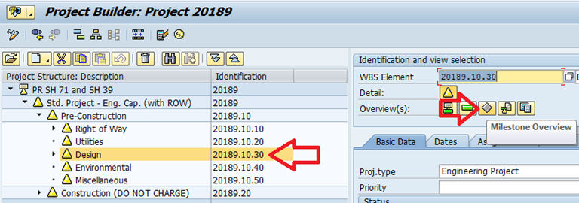

The table of all project milestone will come up, as shown below.

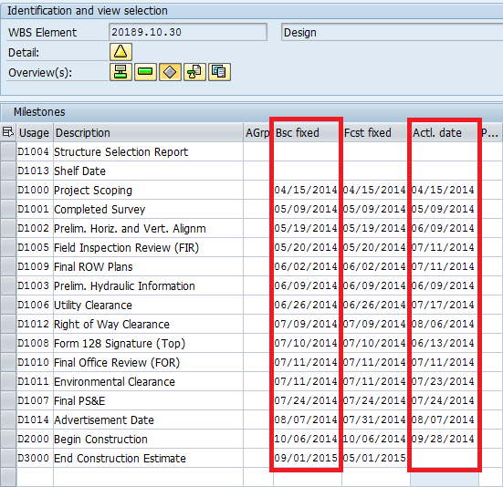

Step 2: Enter dates in appropriate column.
The dates that should be maintained by the RE unit staff are the “Bsc fixed” field (current forecast date), and “Actl. date” field (actual date of milestone). The columns are outlined in red above. The “Fcst fixed” field (baseline date) should be populated at FIR or within the timeframe determined by Region Management. Initial entry of dates in the “Fcst fixed” field activates field locking to capture a baseline. Changes once dates are locked should be coordinated through the Region PMO representative.

The standard SAP names for milestone date fields do not match CDOT’s terminology. The following gives a cross reference for the milestone field names between SAP and CDOT:
Bsc fixed = Current forecast date
Fcst fixed = Baseline Date
Actl. Date = Actual Date

“Bsc fixed” (Current Forecast Date)
The purpose of the “Bsc fixed” field is to keep planned project milestones updated with the latest milestone forecast. This will be the field managed by the Project Manager to communicate the current “plan”. Please keep this field up-to-date with the best milestone estimates currently available.

“Fcst fixed” (Baseline Date)
Once a date is entered into a cell in the “Fcst fixed” field and the project is saved, the cell will be locked (gray). This capability in SAP will be used to set clear expectations of the best estimate a project team has at the time when the information was entered (also called a baseline). This information will be used as a communication tool to discuss changes to an original project plan and calculate Schedule Performance Index (SPI).

If there is a change to a locked cell, access for data modification to the “Fcst fixed” field has been given to the Regional PMO representatives. Current expectations for the “Fcst fixed” field are:
FIR – Initial date is entered with the best estimate
Post FIR – Authority to update requires approval from PE-III and specialty units
Post FOR – Authority to update requires approval from PE-III and RTD.

“Actl. date” (Actual Date)
Once a milestone is complete, the Project Manager will enter the date of completion into the “Actl. date” field.

For re-advertisements, please work with the Region PMO Representative for the appropriate solution.

Step 3: Save
Once updates are complete, click the save button.

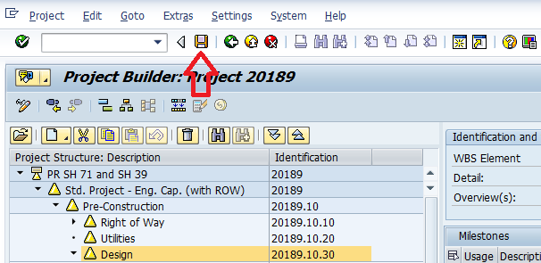

Step 4: Repeat Steps 1 through 3 as directed by Region policy to keep milestones updated with the latest milestone estimates.

The procedures for entering project milestones into SAP have been detailed in Design Bulletin DB 2014-3 and new (dated February 10, 2014) PDM section 1.07.13 “Milestone Dates in SAP Project Builder (CJ20N)”.

References:

Design Bulletins can be found on the CDOT website at:
https://www.codot.gov/business/designsupport/bulletins_manuals/design-bulletins

